Barrier Issues

Overview:
The Barrier Asset
- Continuous
- Has XSP
The Terminal Attributes
- The Begin Terminal attribute represents a physical terminal at the beginning of the barrier
- The End Terminal attribute represents a physical terminal at the end of the barrier
- The Shared attributes signify if the terminal is shared by two separate barriers (typically the end of one and the beginning of the other)
- Although terminals are attributes of the barrier, they must be counted and reported independently. Thus a non-shared terminal counts as 1 and a shared terminal counts as .5.
Requirements
- Barriers split over a distance break or when the EA changes should not increase the barrier or terminal count
- The barrier reports must be able to break down the data in the following ways:
  - Total barrier mileage by an attribute (such as condition, and barrier type)
  - Total barrier mileage by EA and barrier type
  - Total number of barriers by an attribute (such as condition or barrier type)
  - Total number of terminals (1 for non-shared terminals, .5 for shared terminals). This number should not be exaggerated when a barrier crosses a distance break or EA boundary.
  - Detailed listing of individual barriers including begin and end locations (of the whole barrier, not including distance breaks), XSP, and EA. May want to show only the EA at the beginning of the Barrier. (for inventory)
  - Detailed listing of individual barriers including begin and end locations (showing jurisdictional change, milepoint equation or z-mileage and changes in EA), but still only showing 1 begin and end terminal for each unique ID (not one at every break).
Tables and Views
- XODOT_BARR_V: the original barrier view that shows barriers in detail. It is the bases for all of the Barrier tables in the report schema
- XODOT_BARR_EA: The first attempt to fix this issue. We thought the problem was only at EA breaks and only showed up when we reported by EA. This was a faulty assumption. The EA table should go away when we’ve completed this effort. This may require that we make changes to the FI reporting scripts to ensure the barrier data isn’t broken there after this view is removed.
- RPT_ODOT_BARR and RPT_ROADSIDE_BARRIER: reporting tables created based on XODOT_BARR_V
Identified issues in XODOT_BARR_V
(there may be others we haven’t identified, and we don’t know if the XODOT_BARR_EA table has the same issues)
Known Problems | Example
Barrier records are not breaking properly when there is a highway section owned by another Jurisdiction (City, County, etc) which reports segment data incorrectly.  Need example that matches our data. Check their DB | 09100I00  mp -5.82 to 2.00
Distance breaks with a shared terminal or zero mileage  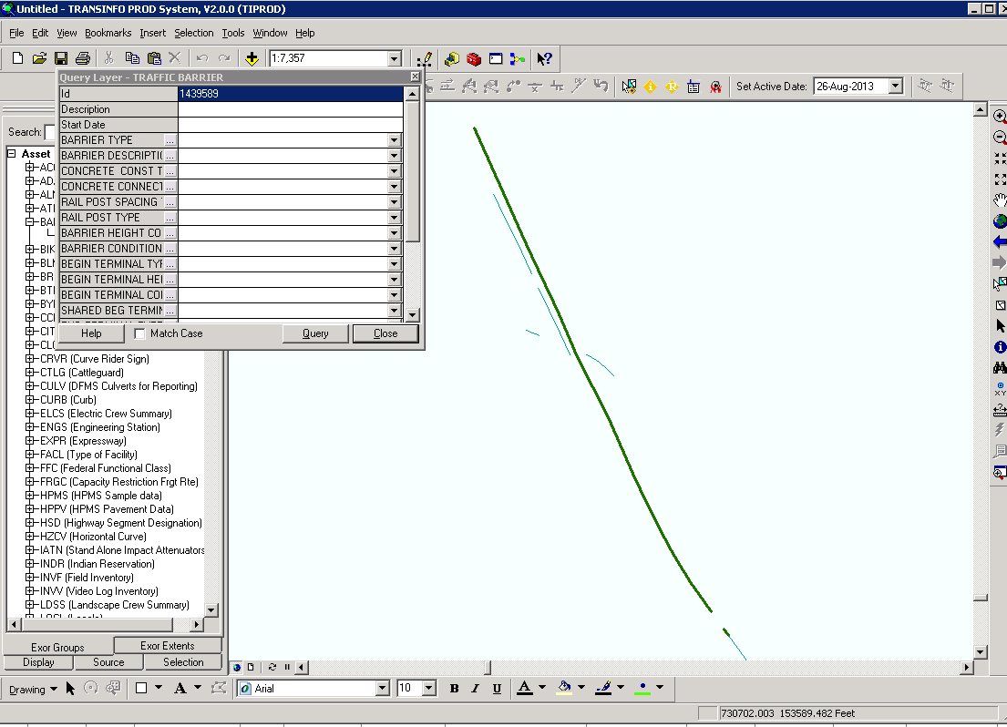 | 00100I00 mp 11.46 - 12.19
When we have multiple locations for a single barrier this reports point (terminal) data incorrectly.

Need example
We currently have barrier records that span 2 EA's (Maintenance number which is used to create the District & Region for every piece of highway). This causes duplicate records to be included in the report (1 for each EA, both carrying the same Primary Key number and all the data for the barrier). | 00100I00 mp 133.47 - 138.85
The totaled barrier length in the Barrier View had 73 miles less of total barrier length from the EXOR Locator tool.

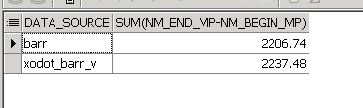
select 'barr' data_source ,sum(nm_end_mp - nm_begin_mp) from v_nm_barr_nw
union all
select 'xodot_barr_v' data_source, sum(end_mp- begin_mp) from xodot_barr_v

Priorities:
- Fix the XODOT_BARR_V table to rollup segments within a barrier, but to show the breaks for distance breaks, z-mileage and EA changes. Remove the XODOT_BARR_EA view.
- Verify that other customizations, such as FI reporting and HBUD are not broken.
- Help ODOT write queries that will roll-up data as specified in the report requirements listed above (thus properly counting terminals and barriers even over distance breaks and EA changes).

